These two paragraphs contains information about the product (ingredients, warnings, benefits, instructions, and so on)

The photo of the product

This is a link to the page where the user can buy the item

The user can see the rating of the product and can rate it themselves

The name of the product

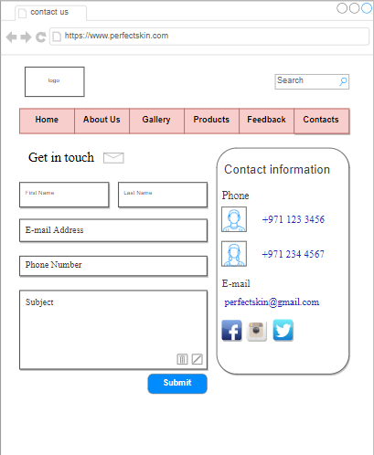

Here are phone numbers the user could use to call directly or send a massage through what’s up

The contact button is shaded after you click on it

Other ways to contact us (when the user click on the icon they will get redirected to our home page in each web site)

When the user is done with the massage, they can click on this button to send it

The user can use this e-mail to send a direct massage

The user will need to fill in these boxes to send a massage and get a reply